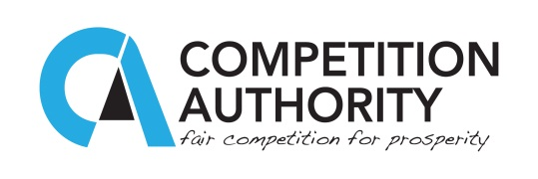

Press Statement 9th March 2016

CA HOSTS 2016 ICN AGENCY EFFECTIVENESS WORKSHOP

The Competition Authority will on Thursday and Friday (March 9th and 10th) host the International Competition Network (ICN) Agency Effectiveness Workshop at Phakalane Golf Estates Hotel Resort which would see up to 60 international delegates descend in Gaborone to attend the huge competition gathering.

The workshop will be officially opened by the Minister of Trade and Industry, Honourable Vincent T. Seretse while Professor William Kovacic, the non-Executive Director of the United Kingdom Competition and Markets Authority will deliver the keynote address.

The International Competition Network (ICN) Agency Effectiveness Working Group (AEWG) is an annual workshop on agency effectiveness which focusses on strengthening institutional efficiency of competition agencies around the world. The gathering brings together experienced competition agencies from developed economies of the first world and fairly experienced agencies mostly from emerging markets and newly established agencies mainly from developing countries. The AEWG primarily focusses on leadership, strategies and management concerns for competition authorities world-wide.

Amongst other things, the workshop is expected to cover such key topics as agency strategy development and implementation, effective project delivery such as investigation procedures, recruitment and knowledge management, accountability and communication, agency ethics, evaluation of procedures, practices and impact of cases.

It is expected that the workshop will provide the much needed practical training skills, sharing of experiences on valuable areas of competition between competition practitioners and administrators. The conference is the first of its kind hosted by the Competition Authority of Botswana.

For any further enquiries please contact Gideon Nkala at 71900900 or [gideonnkala@gmail.com](mailto:gideonnkala@gmail.com)