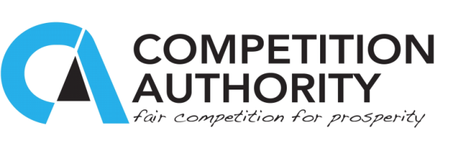

ANNUAL REPORT PRESS STATEMENT BY THULA KAIRA, CEO, COMPETITION AUTHORITY

Tuesday, 20 October 2015

I am privileged to report on our performance and our use of the public resources entrusted to us in this 4th Annual Report of the Competition Authority for the 2014/15 financial year. With each passing year, the consumer, business and Government expectation on deliverables for the Authority have continued to grow. Government in particular has a focus on job creation and competitiveness. The Authority’s operations are expected to create a business environment that is unfettered by any conduct, arrangement or understanding that prevents, restricts and distorts competition (i.e., anti-competitive practices). To this end, I am happy to report that the Authority made a number of interventions in the market that added value to consumers, business and Government through enforcement and advocacy activities.

On enforcement, following the removal of barriers to entry, we witnessed four (4) new market participants in the physiotherapy equipment, sugar supply, the cash-in-transit and alarm & response market and the electrical supply markets respectively. Further, two bid-rigging cases were successfully investigated and referred to the Commission by the end of the financial year. Both cases coincidentally affect Government procurement and were tenders worth P117 million for sugar beans and another worth P10 million for infant formula milk.

The enforcement process was not without bottlenecks. Cases in the car panel beating cartel were withdrawn following discovery that the respondents had not been served with Notices of Investigation while for others there were some procedural errors. To address this, the Authority engaged in re-training of staff in investigations as well as streamlining the coordination of investigations. Further, the Authority engaged KPMG as internal auditors to inter alia, review the investigation process and their recommendations have been under implementation.

There was also an appeal lodged with the High Court against the Commission. The appellants contended that the Commission was likely to be biased since the same Commission members are the board members of the Authority; hence violating the principle of natural justice.
However, that challenge was dismissed by the Commission and the respondents appealed the decision of the Commission at the High Court. The matter was later withdrawn.

We also intervened in a number of mergers. Our target was 35 mergers and we handled 32 (down from 33 in 2013/14). It is estimated that the Authority facilitated the injection of over P145 million into existing businesses in Botswana (i.e., expansion of existing businesses). It further facilitated technological and skills transfer, creation and retention of 740 jobs, as well as citizen empowerment.

On Communications and Advocacy, we engaged in a number of national and international activities. At national level, we engaged in a number of activities on our own as well as in partnership with our strategic partners such as DCEC and PPADB, These engagements focused primarily on awareness around bid-rigging detection and prevention. Such training included Central and Local Government procurement units, parastatals and suppliers to Government. Our adjudication cases also brought a lot of publicity both in the mainstream and social media. These activities earned the Authority the ‘Most Media Visible Parastatal’ award from the Ministry of Trade and Industry.

In this Annual Report, we have reported on notable laws and policies that were influenced to address competition concerns. Competition can be distorted not just by business conduct, but also by laws and policies that are in place. Such laws and policies may be discriminatory in application and/or create entry conditions that frustrate competition.

At regional and international level the Authority has continued to be part of the SADC Competition and Consumer Policies Committee, the Africa Competition Forum, the International Competition Network and the UNCTAD Intergovernmental Group of Experts (IGE) on Competition Law and Policy.

In aggregate terms, the Authority had a performance rating of 82% out of a target of 90%. While this is below the target, it is commendable noting the financial and human resource constraints that we faced in the year. A worthy credit is due to the hardworking staff of the Competition Authority. Thank you so much! The working relationship between management and staff has continued to benefit from open communication, interaction and the assistance of the Commission. I remain concerned about the high case to staff ratio and I am hopeful this would be addressed, in the short term, by engaging Inspectors and Temporary Employees, while we await an organisation-wide restructuring.

I wish to pay tribute to the founding Chairperson of the Commission, Justice Dr Zein Kebonang, who at the end of the financial year, was appointed as acting High Court Judge.
His passion and efforts for both the Authority and the Commission to create the desired impact have inspired all of us. To the Commission, thank you once again for your vigorous and detailed watch over the Authority.

A Modimo o le thuse!

