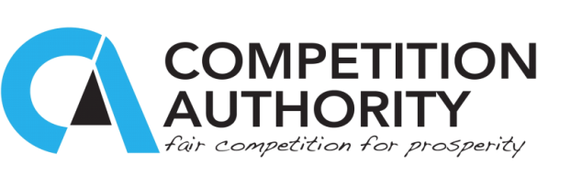

**OFFICIAL WELCOME REMARKS BY THE CHAIRPERSON OF THE COMPETITION COMMISSION DR ONKEMETSE TSHOSA AT THE COMPETITION AUTHORITY AND OECD NATIONAL BID RIGGING WORKSHOP HELD AT CRESTA HOTEL ON TUESDAY, 26TH JULY, 2016.**

_____________________________________________________________

**Honourable Minister of INVESTMENT, TRADE AND INDUSTRY: RRE VINCENT T. SERTSE**

**Competition Commission Members**

**Acting Chief Executive Officer of the CA- Mme Tebelelo Pule**

**Antonio Capobianco: Senior Competition Expert (OECD)**

**Ania Thiemann, Global Relation Coordinator (OECD)**

**Adi Egozi: Competition Expert (Israel Antitrust Authority)**

**Mzi Rubushe, Stakeholder Relations (South African Competition Commission)**

**Management and staff of the Competition Authority**

**Procurement officials here present**

**Distinguished Ladies and gentlemen**

**________________________________________________________________**

1. It is both an honour and privilidge for me to be with you here today at an occasion that I consider to be a major event in our national pursuit to improve our public procurement system.
2. Director of Ceremonies, various entities in this country play a key part in the procurement of goods and services. The Competition Authority is one such organ which plays key part in ensuring that public procurement is fair and competitive. It is our desire to ensure that Batswana obtain goods and services at the lowest possible price to create value for money. This can be achieved through vigorous competition among suppliers. The Authority, with key partners such as the PPADB, has held a number of stakeholder engagements across the country to educate enterprises and public bodies on Bid Rigging. This workshop, however, is the first national workshop that has ever been held, with particular emphasis on Bid Rigging.
3. At this workshop, we have tried to draw representatives from all key sectors of the public procurement system ranging from Government ministries, government departments, parastatals and local authorities including Landboards.
4. While it was our wish, and it remains our desire, to invite everyone that has a role to play in public procurement it would not have been possible to do so. We, however, have faith in the representatives that are here today that they would go out and share the ‘Anti-Bid Rigging gospel’ with many others who could not make it to this workshop.
5. In our midst, we have international guests, who will also share their experiences and we are grateful that they are here with us. Most notably, we appreciate the technical assistance they have rendered.
6. Ladies and gentlemen, we are delighted that you found time to join us here today and I am confident that this workshop would be remembered in posterity as a turning point in our national Anti-Bid Rigging efforts.
7. With these remarks, you are all welcome and I wish you a very productive and fruitful engagement.

Thank you. Le kamoso bagaetsho.