

REPUBLIC OF BOTSWANA

**STATEMENT**

**BY**

**HONOURABLE MINISTER OF INVESTMENT, TRADE AND INDUSTRY**

**BOGOLO KENEWENDO**

**AT THE UNCTAD PEER REVIEW RECEPTION**

**12TH JULY 2018**

**GENEVA, SWITZERLAND**

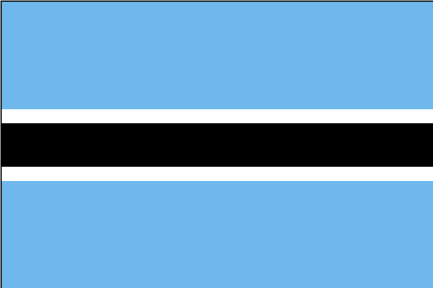

* **Ministers’ here present;**
* **Excellencies, Ambassadors and Permanent Representatives;**
* **Representatives of Government, Inter-Governmental and Non-Governmental Organisations;**
* **Private Sector Representatives;**
* **Members of the Media;**
* **Fellow Batswana;**
* **Distinguished Guests,**
* **Ladies and Gentlemen;**

1. Allow me to start by expressing appreciation that you could join us this evening as we celebrate our first Voluntary Peer Review of Competition Law and Policy of Botswana. In my culture when you invite friends to a function, it is always a mark of reverence when they heed your call. We are therefore truly honored by your presence.
2. My task this evening is not to give an epic speech on some complicated competition policy, but to warmly welcome and appreciate the significant contributions that you have each made in our development path, including through our combined efforts to have an equal footing in the international trade system. It would however, be remiss of me not to re-state the crucial role that a sound competition environment plays in fostering both domestic and foreign investment.
3. The Peer Review mechanism comes at a time when Botswana is undertaking necessary reforms to provide a conducive environment for doing business. It is for this reason that we are keen to implement the advice and guidance we have received today, with aim to ensure transparency in our regulatory environment.
4. I had the opportunity to interact with different stakeholders, including the local media and the private sector amongst others, where we presented Botswana’s value proposition. It is our hope that the message will reach a broader audience and that our market engagements, coupled with exchanges such as the one we just had through a Swiss business delegation in Botswana this week, will translate into long term commercial relations.
5. We can proudly pronounce Botswana as truly a destination of choice for investment, leisure and work. Our central positioning within the region presents opportunities for expansion and exporting to the wider Southern African market. Botswana has consistently ranked highly and positively as one of the best governed, most transparent, most peaceful and least corrupt countries of Africa.
6. As the largest producer of gem diamonds by value, Botswana is establishing itself as a World Diamond Trading Centre, and an obvious choice for diamond manufacturing.
7. We also offer unique and diverse experiences such as; a welcoming environment and friendly people; as well as a prestine tourism experience with a wide range of safari offers, event tourism and adventure, including the Tsodilo Hills and the Okavango Delta which are UNESCO World Heritage sites
8. Botswana is a cosmopolitan, multi-ethnic country that offers a good quality of life. The country continues to develop rapidly and has become a destination of choice to live and work in. We are renowned the world over for our traditional cuisine, specifically our pounded beef, known in Botswana as Seswaa , maize meal or phaleche, and Morogo (a leafy green vegetable) which form the staple diet for Batswana. I am happy to say that we have prepared these dishes to give you a taste of Botswana.
9. As I conclude, I wish to invite you to visit Botswana and participate at the Global Expo 2018 – our Business to Business Exposition, from October 30 to November, 2 this year. The Expo provides an opportunity to scope the local market through business match-making.
10. I implore you to interact, mingle and engage with our personnel to network and learn more about Botswana. I also wish to assure you that Botswana is not only our pride, but your destination.

**PULA!!**