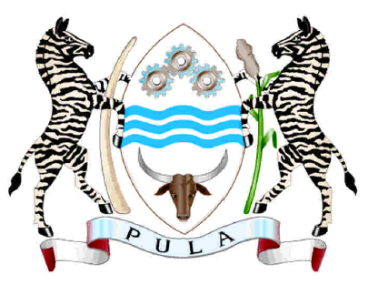
REPUBLIC OF BOTSWANA

SPEAKING NOTES

FOR

HONOURABLE MINISTER OF INVESTMENT TRADE AND INDUSTRY
BOGOLO KENEWENDO

AT THE MEDIA EVENT, PRESS CLUB

12TH JULY 2018
GENEVA, SWITZERLAND

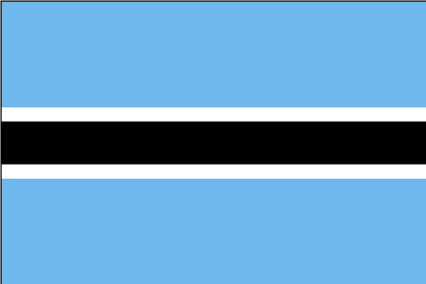

- I am honoured to interact with you this afternoon to present Botswana’s value proposition to the Swiss business community. Botswana is geographically situated in Southern Africa, and the Capital city, Gaborone is 45 minutes away from one of Africa’s largest and busiest economic hubs – Johannesburg.

- Botswana’s central geographical positioning in Southern Africa, makes it an attractive base for launching into the Southern African Development Community’s (SADC) regional market, including South Africa, to supply an estimated market of 277 million people. Further to that, the headquarters of the SADC Secretariat are in Botswana.

- Botswana stands out as a regional leader on several key desirable attributes that are highly sought by international investors. Some of the pertinent strengths that have made Botswana to stand out from her African peers include but not limited to;

- No foreign exchange controls or restrictions on business ownership;
- Taxes are very low – 15% for manufacturing, IFSC and Innovation Hub companies, maximum 22% corporate tax for other sectors; and maximum 25% for individual;
- Consistently ranked highly by sovereign credit rating agencies S&P A-/A-2 and Moody’s A2; Rankings are premised on strong external and fiscal balance sheets, low public debt, robust institution and well-designed macroeconomic frameworks amongst others.
- Duty – free import of machinery and equipment for manufacturing purposes;
- Sound monetary policy with low inflation rate (3.3 May 2018 against inflation targeting of 3 – 6 percent; Bank rate 5 % prime lending rate 6.5%; Exchange rate policy – crawling peg).
- Educated and peaceful workforce (82% are literate) and most speak English, government allows for 200% tax allowance for training costs;
- Preferential incentives in Special Economic Zones;
- Middle income country with GDP of US$17.30 billion and GDP per Capita of US$ 7 570
- Effective investor facilitation through the Botswana One Stop Service Centre (BOSSC)

- Notwithstanding these key accolades, Botswana has not attracted the much-desired foreign direct investment including economic diversification. It is for this reason that I am here to extend an open invitation to Swiss businesses that seek to take the first mover advantage into Africa to consider setting their projects in Botswana.

Why Switzerland?

- First, Botswana stands to learn a lot from the country that has consistently ranked as the world’s most competitive economy for many years consecutively by World Economic Forum. The 2017-18 Global Competitiveness report continues to shed light on the key attributes that differentiate Switzerland from the rest of the world; with strong results evenly balanced across the different components of competitiveness. According to the report, the economy of Switzerland is built on several strong fundamentals including public health, primary education, and a comparatively solid macroeconomic environment.

- In comparative terms, Botswana has often been hailed as the “Switzerland of Africa” owing to the resiliency and prudent management of her economy. The Global Competitiveness Report 2017-18 bears testament to this fact where the country stands out on several of the twelve pillars. Botswana ranked 13th out of 137 countries on the soundness of the macroeconomic environment; 40th in terms of labour market efficiency and 45th in terms of soundness of institutions.

- Second, it is documented that Switzerland is home to several multinational corporations, in the areas of pharmaceuticals, manufacturing (watchmaking), machinery, and banking. The Swiss economy is dominated by the services sector, which accounts for about 75% of the GDP’s share where the financial services play a critical role, drawing 12.9% of the GDP’s share. Other key economic indicators include low levels of taxation, high standards of education, reliable infrastructure, and flexible labour laws; these render the country a particularly attractive destination for foreign investment, which, in turn, helps the country to retain its fierce competitive edge.

- These key sectors align perfectly with Botswana’s priority sectors and provides an attractive opportunity for Swiss businesses seeking to invest in emerging sectors such as mining beneficiation (diamonds, soda ash etc), financial and business services, commercial agriculture and agro-processing, cargo and logistics, manufacturing (including automotive components and parts), and ICT to consider Botswana for their Africa operations.

- Third, Botswana and Switzerland have committed to promote trade through the SACU-EFTA trade Agreement, which is the first agreement to be signed by SACU members as a collective. Trade data show that between 2012 and 2017, Switzerland overtook Norway to be the highest export market for Botswana products within the EFTA States. Botswana exports grew from 776 million Pula in 2012 and reached a peak at 2522 million Pula in 2015 and declined slightly in the following years. In 2017, Botswana’s exports to Switzerland were valued at 1457 million Pula and comprised of diamonds and Gold. On the other hand, imports from Switzerland has been insignificant and comprises mainly goods from HS 85 - electrical machinery and equipment. Notwithstanding the above, there is still potential to diversify export products into the Swiss market.

- Fourth, Switzerland is home to Inter Governmental Agencies such as UNCTAD, International Trade Centre, WTO, WIPO, ILO, WHO to name but a few, and Botswana like any other emerging market, would seek to benefit immensely from technical capacity building initiatives targeted at strengthening trade and industrial policy environment including the growth of private sector.
- According to fdi Markets 2018, Switzerland falls in the top 10 source countries for greenfield investment between 2003 and 2017. Around 4634 projects are estimated to originate from Switzerland, with a total CAPEX of US$309 130.60 millions, generating 483 922 jobs globally. However, Botswana has not benefited from the Swiss Global FDI expansion. At present, there is only one registered manufacturing company with Swiss partnership in Botswana. The company has invested around 4,5 million Pula to manufacturer electrical products for the UK, South Africa and Singapore export markets. This company has created 33 jobs for Batswana.
- I want to take this moment and assure the Swiss business community that my Government is the process of undertaking reforms, necessary to facilitate ease of doing business in Botswana. In August 2016, the Botswana Economic Committee of Cabinet, chaired by His Excellency the President of the Republic of Botswana approved implementation of a set of reforms aimed at revitalizing the Botswana IFSC offering. Further to that, Botswana defended her tax regime under the OECD to be white listed as a viable/authentic tax jurisdiction in September 2017. The OECD has listed Botswana as “compliant” pending further review of one area around ring fencing, a process that is expected to be completed in December 2018.
- Botswana is committed to avail conditions for doing business that are attractive for investment, creating a facilitative regulatory environment, supportive infrastructure, and a competitive and highly productive workforce. We aim to open our economy and our country to the global world and to international expertise and know-how, and to make foreign investors feel most welcome.

- In conclusion I urge all the media and other key stakeholders present here today to partner with; and constructively engage to sell the Botswana story to the Swiss business community. I also invite you to visit Botswana from October 30 – November 2 where we will be hosting our premium business to business exposition, the Global Expo. My team is available to share more details regarding other opportunities of interest to you.

- I thank you for your attention. PULA!!!

