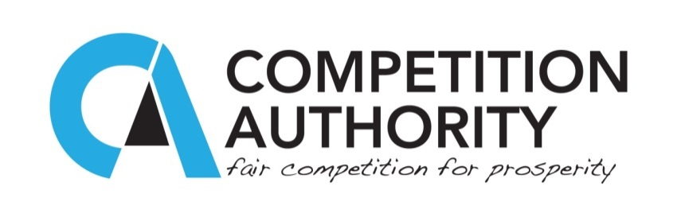

**WORLD AIDS DAY BRIEF TO STAFF BY THULA KAIRA**

**CEO, COMPETITION AUTHORITY BOTSWANA**

***1ST DECEMBER 2014***

Thank you all for finding time from your busy schedules to commemorate for the third time at the Competition Authority, the World AIDS Day. The message of HIV/AIDS, has perhaps become too monotonous for most of us and to an extent, a number of us may feel we have too much information already. Again, there may be a category of us who may feel we are above a certain age group and we are not in the risk category - or perhaps that we have been there, done it and survived, so what’s new? These are legitimate scenarios which we cannot ignore, and perhaps communication messages have to change or adapt accordingly.

The following are pertinent questions. Why should we as a Competition Authority be concerned about HIV/AIDS? Why should we commemorate this day each year, despite our vast knowledge, experiences and perhaps age? I would like us to reflect on these questions by referring to Section 5(1) of the Competition Act (46:09), which provides the framework of our role: to prevent, redress and remove anti-competitive practices in the economy. All of us have heard this sentence so many times since 2011 when the Authority was established. I would like to borrow the same language of ‘prevention’, ‘redressing’ and ‘removal’ to illustrate why we should continue to commemorate and remind each other of HIV/AIDS.

**Prevention of new infections**

Prevention of HIV/AIDS infections is a matter that we should be concerned because, while there are ARVs to deal with HIV/AIDS, the best remedy remains that of preventing new infections. We as Team CA can prevent new infections amongst ourselves and our beloved by ensuring that we keep ourselves free from casual, illegal and immoral sexual activities. Why should we focus on sex? Is sex the only cause of HIV infection? No, sex is not the only cause of HIV infection, but the statistics are clear that most people in our part of the world contract HIV through sexual contact.

Increasingly male-to-male sex relations are being identified as another source, and some of those who engage in this conduct are married to females. We thus need to remind ourselves of these new realities and together seek ways of how we can prevent new, multiple or exponential infections. There is no better day to get your attention than on this World AIDS Day.

**Redressing existing mistakes**

Redressing is about rectifying or remedying something. How can we remedy or correct our actions in relation to HIV/AIDS? We can do so by looking at our own existing sexual activities. Where we have made mistakes and by God’s grace we have not contracted HIV or AIDS, we need to ensure that we do not repeat the same mistakes. Where we have been planning to play or are already playing with fire, let us ask ourselves whether we are ready to live with the burns. The pleasures we seek are normally not as pleasurable when we actually find them. The old saying is actually true: Not all that glitters is gold. The world has come up with what are promoted as correctional methods such as male and female condoms, safe male circumcision and so forth. While these are recommended as providing some degree of protection, they do not insulate one from HIV/AIDS. Increasingly nowadays, we are being tuned to the understand that morality is a personal issue but you would agree with me, I hope, that the good old morals of ‘chastity’, ‘being faithful to one partner’, and so forth remain the best solutions.

**Removal of barriers, myths and ignorance**

I appeal to you that we need to remove from our minds any feeling of indifference towards HIV/AIDS messages. While we may have had enough, our sexual partners or spouses may not be as knowledgeable. We need to use such opportunities as World AIDS Day to remove barriers to discussions and make this topic one of the intimate discussions we should have with our sexual partners. Let us remove the myth that we cannot discuss the topic with our teenage daughters and sons who are exploring and vulnerable to learn from the most destructive forces. Where we have our heads in the sand and hope that by the time our head is out we will see the problem no more, we need to remove our heads right now because the problem requires our conscious and active intervention. Let us remove the fear to go for Voluntary Counselling and Testing (VCT) and get to know our status and that of our sexual partners. Let us remove the ignorance of not knowing our HIV/AIDS status. Let us remove the myth that knowledge of one’s HIV/AIDS status will bring about depression, public shame, loss of lovers or spouse, enjoyment of life, and so on. I believe that we at the CA do not and should not hold on to such myths.

**Finally**,

Allow me to end by quoting Hosea 4:6, which says: ‘my people perish for lack of knowledge’. We can learn a lot from this verse. There are people who have knowledge but behave totally the opposite to the knowledge they profess to have. There are some people who do not have knowledge at all, some have the knowledge in a distorted context. HIV/AIDS does not only require knowledge, it requires us to have the right knowledge and to use the knowledge correctly and consistently so to help ourselves, our workmates, our friends, our spouses, our lovers, our families, our communities to adopt a healthy sexual life-style and learn to manage HIV/AIDS like any other chronic illness or disease. There is no need for fear, there is no need for ignorance on status, there is no reason why we should not just commit to have zero HIV infection, zero discrimination and zero deaths due to HIV/AIDS at the Competition Authority.

Bagaetsho, Modimo a le segofatseng!